Operation Manual
HM601 Oil Dielectric Loss and Resistivity Tester

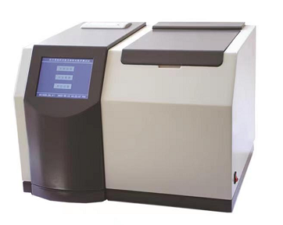

WUHAN GOLDHOME HIPOT ELECTRICAL CO.,LTD

Tel.：+86-13720185294 Fax：+86-27-84625205
Email：goldhome02@cablehipot.com Web.: www.hvcablehipot.com
Add.: No.A25-1, Huading Mould Industrial Park, Hannan, Wuhan, Hubei, China

Dear users:
Thank you for choosing my company oil dielectric loss and electrical resistivity tester.In order to let you skilful operation of the instrument as soon as possible,Provided us with the detail operation manual,From which you can get the product introduction, the use of methods, equipment performance, and security considerations, and many other aspects.
Before the first use of the instrument,Please read the operation manual carefully.And according to the manual of instrument operation and maintenance,This will help you better use of the product and can prolong the service life of the instrument.
At writing manual, we are working in line with the scientific and rigorous attitude,And that information provided in this manual is correct and reliable.However, even Homer sometimes nods, this manual also hard to avoid can have errors and omissions.If you find the errors in the manual, please try to inform us as soon as possible,To supervise and we correct mistakes as soon as possible!
The company reserves the right to improve the instrument use function,Such as found in use process of the instrument of its function and operation manual,Based on the actual function of the instrument, please shall prevail.We hope that the instrument can make your job easier, happy,Make you in the busy work experience the lightness of office automation.When you are satisfied with this instrument, please recommend to your friends!When you have opinions and Suggestions to this instrument, please contact with us,The company will try our best to give you a satisfactory answer.Thank you again for your support to our company!

Content

One : Overview 5
Two : The main functions and characteristics 5
Three : The main technical indicators 7
Four : Conditions of use 8
Five : Panel and operation points for attention 8
Six, the operation method 13
Seven : Cleaning and installation method of oil cup 17
Eight:Test method 20
Nine, common faults and processing methods 21

One : Overview
Automatic precision oil dielectric loss design and manufacture according to GB/ t5654-2007 "measurement of relative capacitance, dielectric loss factor and dc resistivity of liquid insulation materials".Used for measuring dielectric loss factor and dc resistivity of insulating liquid dielectric such as insulating oil.Integrated structure.Internal integration of dielectric loss oil cup, temperature controller, temperature sensor, dielectric loss test bridge, ac test power supply, standard capacitor, high resistance meter, dc high voltage source and other main components.The instrument is equipped with a 5.7-inch TFT pure color LCD touch screen and a Chinese menu. The test results can be stored and printed out automatically. The operator can use it skillfully without professional training.

Two : The main functions and characteristics
（1）Oil cup of the accord with national standard GB/T5654-2007 three electrode type structure, the electrode spacing 2 mm,Can eliminate the stray capacitance and xie's influence on the dielectric loss test results.
（2）Instrument by medium frequency induction heating, PID temperature control algorithm.The heating mode with oil cup with non-contact heating body, heat evenly, high speed, convenient control,Make temperature strictly controlled within the preset temperature error range.
（3）Internal standard capacitor for SF6 inflatable three pole type capacitor, the capacitance of the dielectric loss and capacitance is not affected by environmental temperature, humidity,The instrument accuracy after long time use is still guaranteed.
（4）Test AC power supply adopts AC - DC - AC conversion method,Effectively avoid the mains voltage and frequency fluctuations impact on dielectric loss test accuracy,Even if is a generator, the instrument can also run correctly.
（5）Perfect protection function.When over voltage, over current, high voltage short circuit,Instrument can quickly cut off the high pressure, and send out a warning message.. When the temperature sensor failure or not connected, the warning information.In the medium frequency induction heating furnace with finite temperature relay,When the temperature over 120 degrees, the relay release, stop heating.
（6）Parameters setting is convenient.Temperature set range of 40 ~ 120 ℃,Ac voltage setting range200 ~ 2200 v,0 ~ 500 v dc voltage setting range.
（7）Adopted the pure color TFT LCD touch screen display, show clear.Simply set, the instrument can automatically test.And automatic storage and print the test results.
（8）Built-in real-time clock, the test date, time may be retained with the test results, display and print.
（9）Empty cup electrode calibration function.Measure the empty cup electrode capacitance and dielectric loss factor, cleaning and assembly of electrode to determine empty cup.Calibration data is automatically saved for relative permittivity and precise calculation of dc resistivity.
（10）Instrument RAM9 platform as the core, high precision, high speed.

Three : The main technical indicators
The power supply voltage： AC 220V±10%
Power frequency： 50Hz/60Hz ±1%
Measuring range： Capacitance 5pF～200pF
The relative permittivity 1.000～30.000
Dielectric loss factor 0.00001～100
The dc resistivity 2.5 MΩm～20 TΩm
Accuracy of measurement： Capacitance ±(1%reading+0.5pF)
The relative permittivity±1%reading
Dielectric loss factor±(1%reading+0.0001)
The dc resistivity±10%reading
Points and distinguishing rate：capacitance 0.01pF
The relative permittivity 0.001
Dielectric loss factor 0.00001
Temperature measurement range： 40～120℃
Temperature measurement error： ±0.5℃
The ac voltage： 200～2200V Continuous adjustable, frequency 50 hz
The dc test voltage： 0～500V Continuous adjustable
Power consumption： 100W
Type or outside： 460mm× 370mm×330mm
Total amount of： 25Kg

Four : Conditions of use
The environment temperature： 0℃～40℃
Relative humidity： <75%

Five : Panel and operation points for attention
1、Caption

The printer
Oil cup warehouse
display
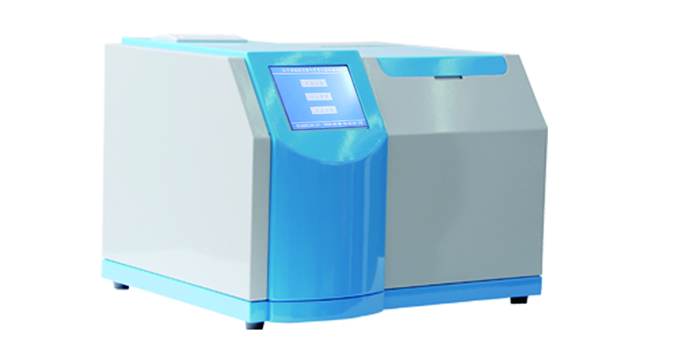

Figure 1, instrument display

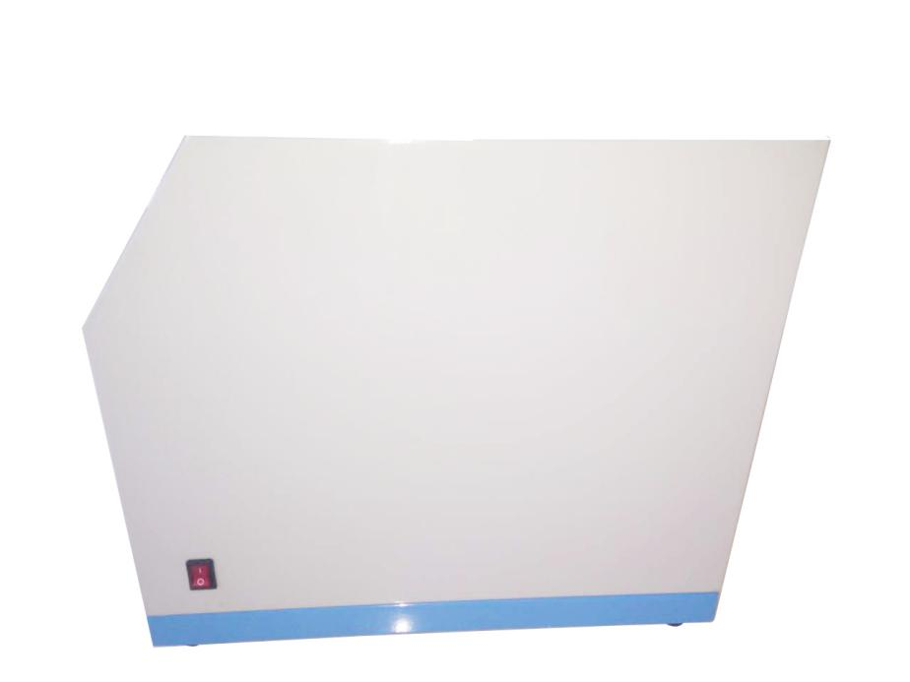

The power switch

Figure 2 instrument side

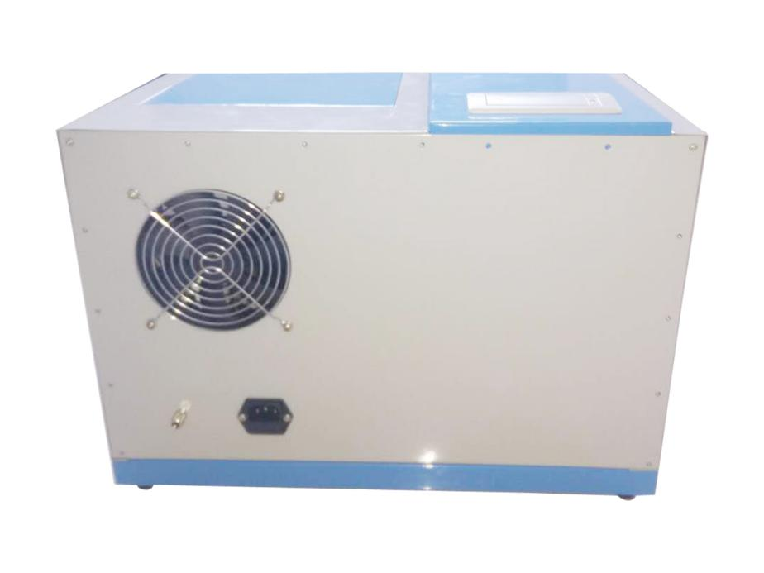

A cooling fan

A power outlet
Grounding column

Figure 3 on the back of the instrument

Temperature measuring jack
The test socket
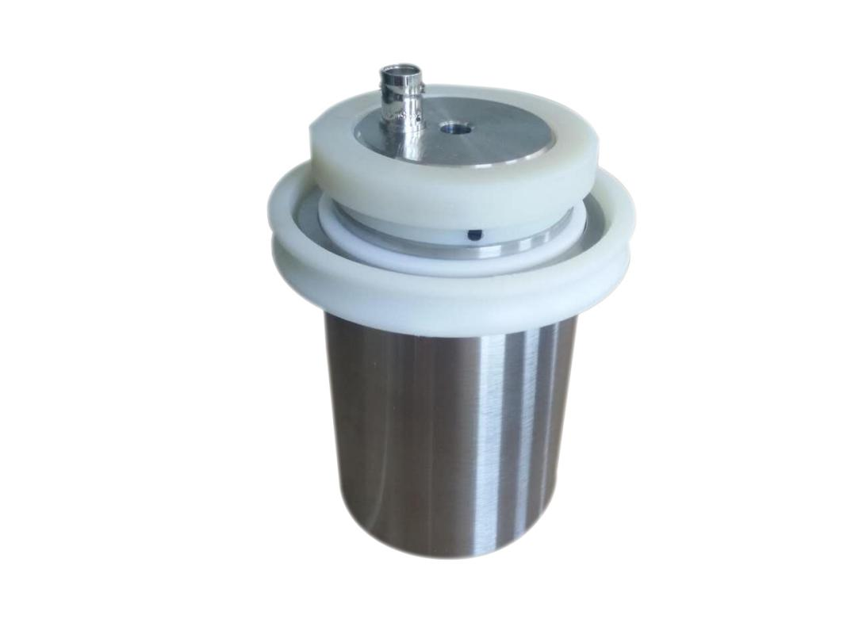

Figure 4, oil cup display

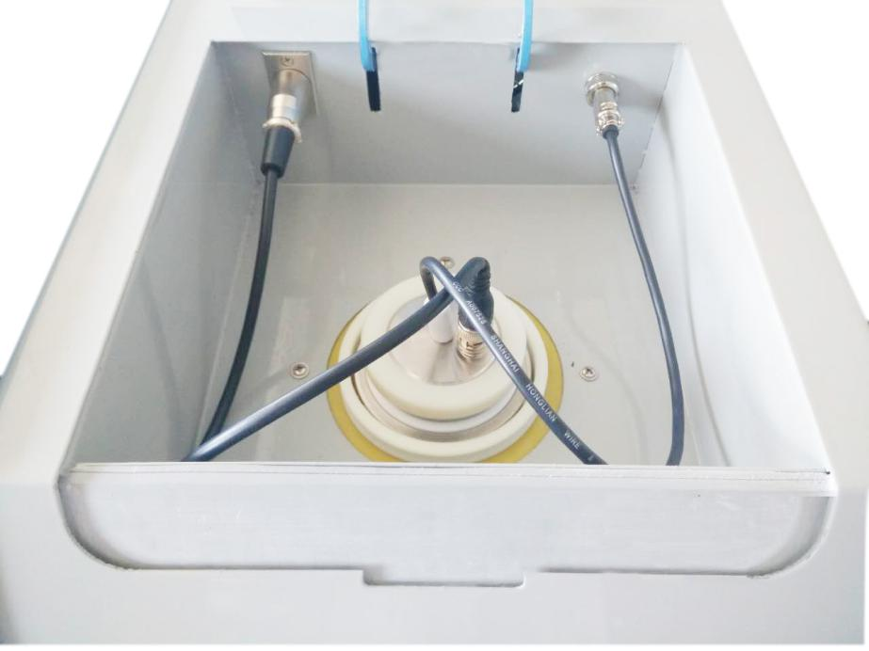
The temperature signal
Current signal
Figure 5, oil cup

2, Instrument operation
⑴ Instrument should be reliable grounding, power entry into AC220V power.
⑵ Open the lid, can remove oil cup, heating and the dielectric loss test, box cover should be closed.
⑶ Lid has a cover to protect, opened the lid, interrupts heating and high pressure.
⑷Test process, the internal high pressure and high temperature, oil cup is not permitted in the electricity and testing contact and cable and plug.
⑸ When placed oil cup, should carefully to avoid oil into the oil cup of the tank.
- If you need to do to test the empty cup, to oil cup according to the operation manual cleaning, drying, assembling, heating up to 50 ℃ after the experiment.
- when the instrument is submitted for inspection, the current detection line must be linked according to the line sequence of our company (connector 1.3 pins are connected positive and 2 pins are connected negative).If you have any questions, please contact our technical service department.
Using the proper power cord.Can only use this product is special, and conform to the product specifications of the power cord.Connect and disconnect the correctly.
Products are grounded.This product except through the power cord grounding wire product enclosure grounding column must be grounded.In order to prevent electric shock, the grounding conductor must be connected to the ground.Before with this product input or output terminal connected, should ensure that this product is properly grounded.
Note that all rated capacity of the terminal.In order to prevent fire or shock hazard, please pay attention to the product of all ratings and tags.Before to connect to our products, please read the product instruction for use, in order to further understand the information for the rating.
Using the appropriate insurance tube.Only can be used in accordance with the provisions of this product type and rating of insurance tube.
When a malfunction in the suspicious, please do not operate.If you suspect that this product has a damaged, please relate this company maintenance personnel for inspection, please do not continue to operate.
Please do not operating in a wet environment.
Please do not operation in explosive environment.
Keep clean and dry surface.
Special reminder: this instrument has high voltage output, improper use may endanger personal safety.Before using the instrument, be sure to read the instruction manual carefully first!

Six, the operation method
1.Will clean the oil cup into the oil cup slot,And connect the test cable (as shown in figure 5).
2.starting up
Open the power switch,Liquid crystal display (figure 6) is shown in the main menu.
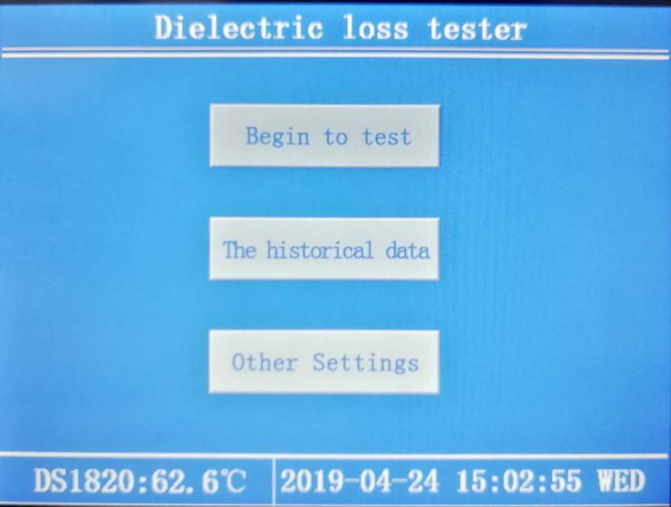
Figure 6
3, test conditions
Enter the "start test" parameter Settings screen (figure 7).
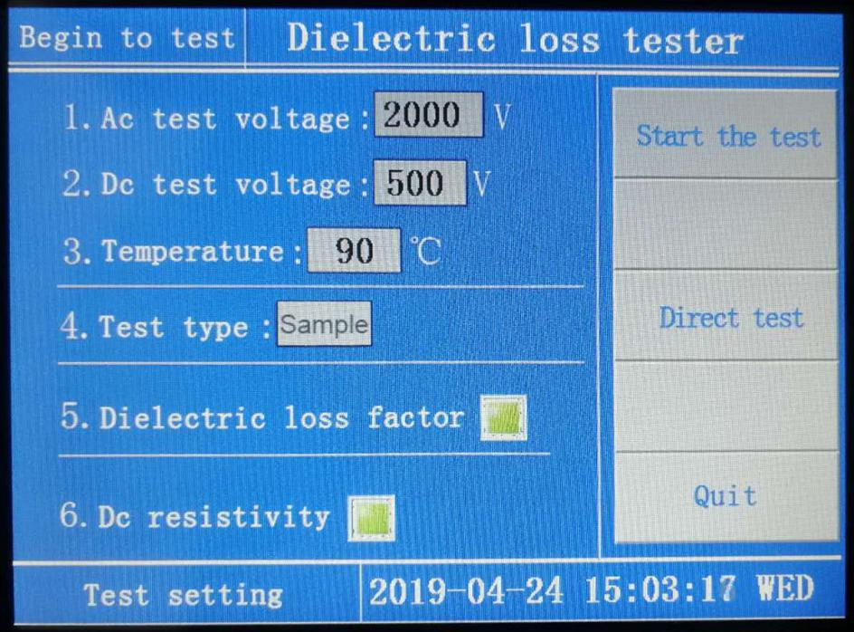
Figure 7
- parameters：Ac voltage： AC 200~2200V
Dc voltage： AC 0~500V
Test temperature： 0～120℃
Test type：Samples or empty cup
Dielectric loss factor：Light green, when selected [test];Dark green without test.
The dc resistivity：Light green, when selected [test];Dark green without test.
（2）Parameter setting method
Press "ac test voltage" pop-up keyboard interface as follows (figure 8).On the keyboard input data.Beyond the scope of input.
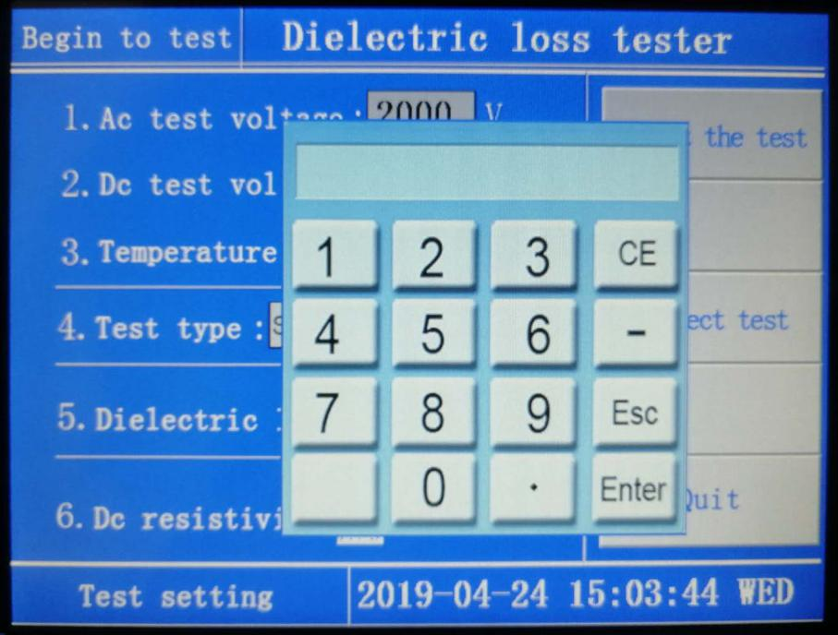
Figure 8.
According to [the dc test voltage] or [test temperature] key,Steps the same as the input [ac test voltage] method.
When set to [test type ] [samples] after test the samples.
When set to [test type ] [the empty cup], after testing the empty cup.
Dielectric loss factor.
Light green, when selected [test];Dark green is not test, press the touch screen related position switch.
（4）Dc resistivity.
Light green, when selected [test];Dark green is not test, press the touch screen related position switch.
Press [start test], enter the test interface, according to the set parameters test.
Press [direct test], enter the test interface, skip the heating process, directly according to the set parameters Settings.Press [exit]to return to the main menu.
The historical data
Press "historical data", pop-up keyboard interface as follows (figure 9).
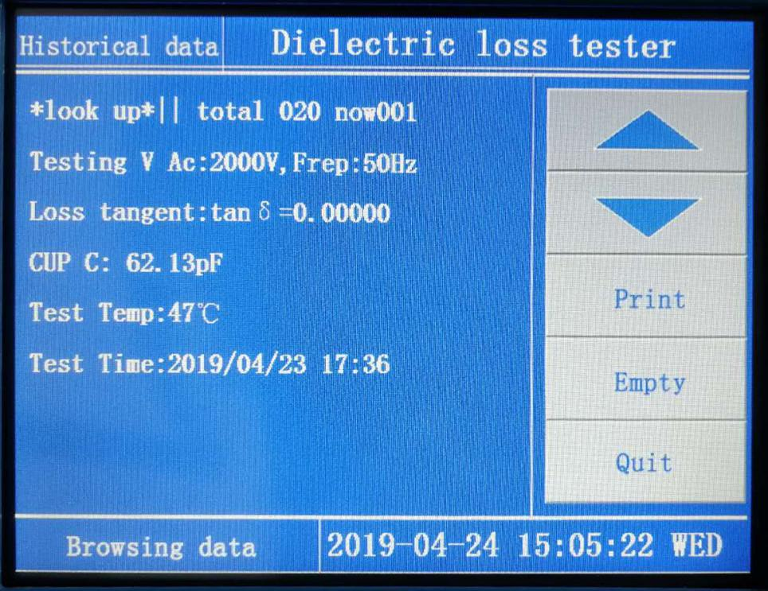
Figure 9
Press "up and down button" for reading.
Press "print" to print the current page number.
According to the "data to empty ", empty storage historical data.
Press "exit" from the current interface.
5、Other Settings
Press "other Settings" button and enter the other data set screen (figure 10).
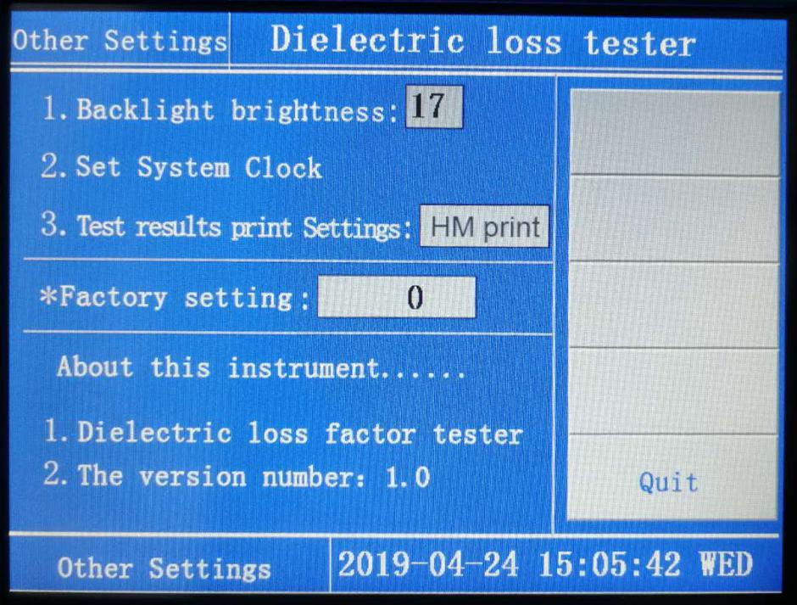
Figure 10
Press "set the backlight brightness", pop-up keyboard, input a brightness values.
Press "set the system clock", pop-up keyboard, simply enter the current time.
Press "print setup", will be in the "manual print" and "print" automatically switch between,If choose "automatic print" instrument testing is completed, will automatically be printed.
Press "factory set", the key for the manufacturer to upgrade retained a key, do not use.

Seven : Cleaning and installation method of oil cup
1、The technical index of the oil cup
Plate spacing：2mm
Capacitance of the empty cup：60±5pF
The oil cup capacity:≤40ml
Empty glass dielectric loss value: ＜5×10⁻⁵
2、Assembly method (disassembly steps instead)
Oil cup parts as shown in figure 11：
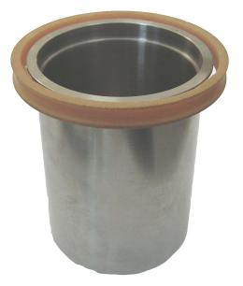
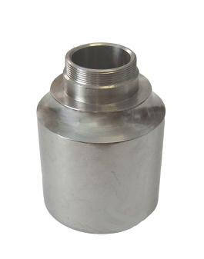
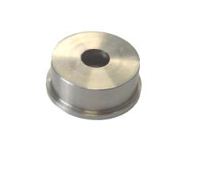
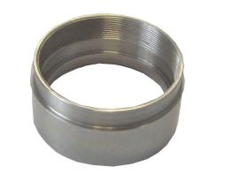

1 2 3 4

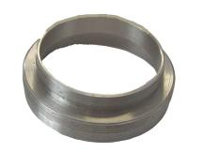
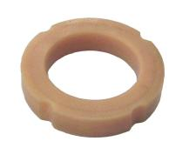
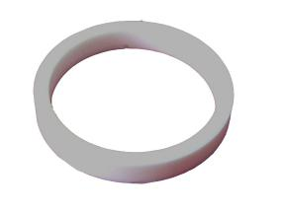
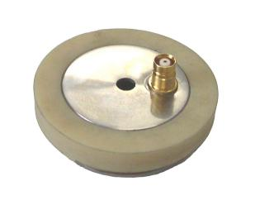

5 6 7 8
Figure 11
Oil cup assembly parts diagram
After cleaning the parts banned direct contact with the hand,Good class silk gloves must be worn when assembling,According to the following steps.
a.Will be insulated ring (6) into the shielding electrode (4).
b.The two sets of on low voltage electrode (2).
c.The low voltage electrode nut (3) tight on the low voltage electrode (2).
d.Will block electrode nut (5) tighten on the shielding electrode (4).
e.Insulation ring (7) set on the shielding electrode (4).
f.Will oil cup shielding electrode (8) tighten the nut (5).
g.Above will assemble body gently into the high voltage electrode (1), assembly is complete.
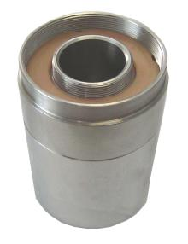
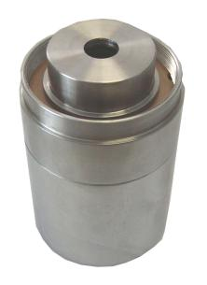
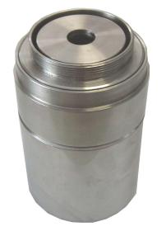
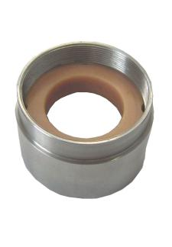

Step a Step b Step c Step d

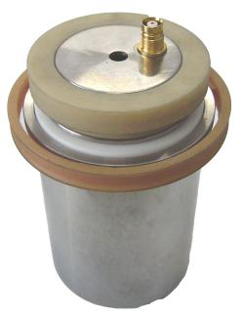
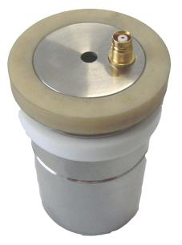
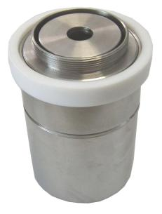

Step e Step f Step g

3、Cleaning method
In the measurement of insulating oil loss value, it is important to clean the oil cup preparations.Some measurement results not credible, is often caused by oil cup clean incomplete,Therefore must follow strict cleaning method, can get good repeatability and reliable measurement results.
Do the loss factor of insulating oil evaluation test,Before each test should be thoroughly clean the oil cup,Cleaning steps are as follows：
A. The oil cup completely apart,In turn, chemically pure petroleum ether (distillation range of 60 ~ 90 ℃) and benzene to clean all parts.
B. Using acetone to rinse all parts, and then clean with neutral detergent.
C. Put all parts in the distilled water solution of 5% trisodium phosphate boil for 5 minutes,Then rinse with distilled water several times.
D. Put all the parts in distilled water to boil at least 1 hour.
E. Put all the parts in the temperature control in 105 ~ 110 ℃ oven drying,Drying time not less than 1 hour.
F. All parts to be cold to hot, assemble the oil cup.
Note: while doing the loss factor of insulating oil general routine test,Cleaning method can simplify the oil cup,Is the cleaning method of the c item and the item d slightly,Instead of all parts will be a few times, rinse thoroughly with distilled water directly into the first e items.
In addition, when continuous make routine test on a batch of sample,If the first sample the loss factor of less than the specified value, criterion when doing the next sample can not wash oil cup again,But it must be with the second sample washing oil cup three times or more.

Eight:Test method
Due to the reason of the test product itself, there are many factors causing the error of the oil dielectric loss value. The following is the test method provided in the measurement standard for dielectric loss factor of liquid insulating material in GB/T 5654-2007 for reference only.
Test voltage
The ac voltage depends on the liquid being measured, and the electric field strength ranges from 0.03 kv/mm to 1 kv/mm, using sinusoidal voltages with frequencies ranging from 40 to 62 hz.

Nine, common faults and processing methods
1. When starting up, the power switch indicator light is not on. Please check whether the fuse of the power board is fused or not.
2. When the device is boosting, the liquid crystal display "electrode cup short circuit", please check whether the electrode cup is properly assembled.
3. When the device detects that the empty cup capacitance deviated from the standard value (60pF±5pF), please check whether the rf head on the power signal cable protection electrode cover is loose.
4. When the equipment heats up, the temperature signal cannot be detected. Please check whether the temperature signal cable is connected correctly.

